EXP NO 5:CREATE A SIMPLE CLOUD SOFTWARE APPLICATION FOR LIBRARY BOOK RESERVATION SYSTEM FOR SIMATS LIBRARY USING ANY CLOUD SERVICE PROVIDER TO DEMONSTRATE SAAS.
AIM: To design and deploy a cloud-based Library Book Reservation System for SIMATS Library using Zoho Creator to demonstrate the Software as a Service (SaaS) model.

PROCEDURE:
- Open https://creator.zoho.com and log in using a Zoho account.
- Click Create Application → Blank App.
- Enter the application name as SIMATS Library Book Reservation System and click Create.
- Create one form named Library Book Reservation Form.
- Set required fields and basic validation where necessary.
- Save the form and enable user access permissions.
- Create a Report from the same form to view all book reservations.

OUTPUT:
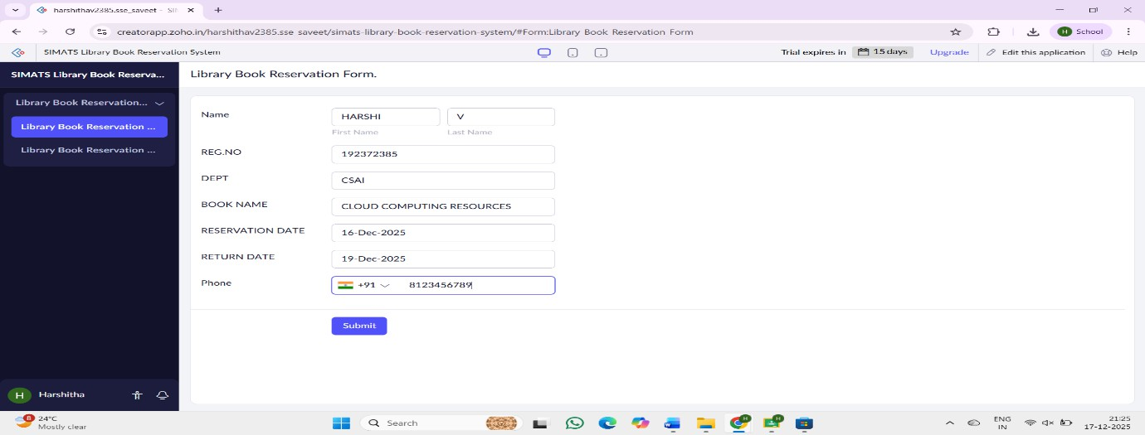

RESULT:
A cloud-based Library Book Reservation System for SIMATS Library was successfully created and deployed using Zoho Creator, demonstrating the SaaS cloud computing model.

